04/06/20
THM 348 Service Operations Management
Final Exam Answer Sheet
- In its effort to improve the quality of online education at Bilkent University, the office of the rector analyzed various feedbacks sent by stakeholders (students, educators, administrators…). The following problematic areas along with their frequencies were reported for the first 3 weeks of online education:
- Prepare a Pareto Chart for the above data. (2 Points)

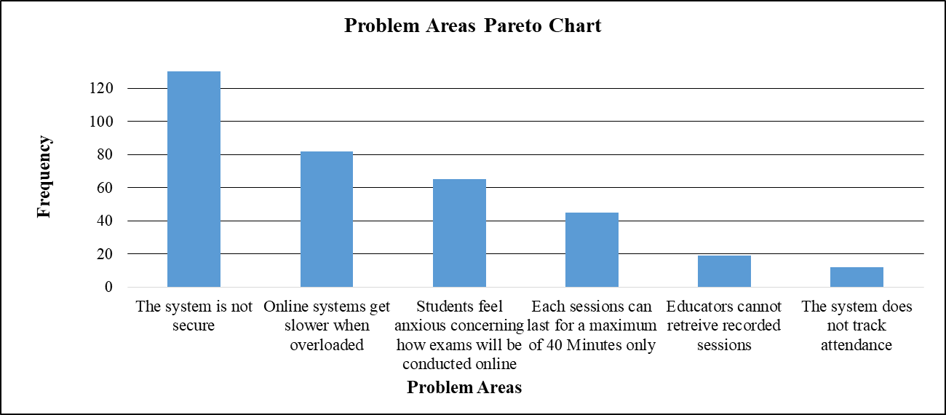
- As “The system is not secure” problem had the highest frequency amongst the other problems, Bilkent University’s rector ship decided to tackle it first. In this regard, passwords needed to access online rooms started to be generated on a daily basis instead of being fixed. For the next 3 weeks, the number of feedback sent related to security issues turned out to be 33. Is there any improvement, related to security issue, as far as stakeholders’ feedbacks are concerned? If there is an improvement, what is the next problem that Bilkent University’s rector ship shall try and solve? Explain the reason behind your answer. (1 Point)
As the number of feedbacks concerning “The system is not secure” decreased from 168 to 33, there seems to be a significant improvement. Moreover, the next problem that Bilkent University’s rector ship shall try and solve is “Online systems get slower when overloaded”. The reason behind this approach is that this very problem received the second highest frequency (feddback wise) among the other reasons.
- Prepare a fish-bone chart for the next problem to be tackled. Come up with at least one possible cause for each category. (2 Points)

Equipment
Service Deliverer
Procedures
Attendees
Other

The answer here varies from one student to another. Hence, there is no definite set of causes. (Check students’ answers and their relevance to the problem as well as to the category in the fish-bone chart.
- What are the advantages of an “Omnichannel” Supply Chain? (2 Points)
The advantages of an omnichannel supply chain are as follows:
- Allows for higher service levels at lower cost
- Consolidates demand
- Lower inventory levels
- Allows customers to check their order status
- What are the four important characteristics for a service to be described as “Professional Service”? (2 Points)
The four important characteristics for a service to be described as professional service are as follows:
- Service shall involve a high level of specialization and customization.
- The frequency and importance of face-to-face interactions with customers require special attention.
- Service shall be delivered by highly educated professional people who represent the assets of the firm.
- Service providers shall possess different knowledge skills ranging from cognitive knowledge to self-motivated creativity skill.
- What problems might arise from franchise contracts favoring franchisers? (2 Points)
Problems that might arise from franchise contracts favoring franchisers can be as the following:
- Misuse of power by franchiser
- Abuse of power by franchiser
- Ambiguities regarding the responsibilities of the franchiser
- High potential of future misunderstandings / litigations between franchiser from one hand and franchisees from the other.
- How can global companies try to neutralize their exposure to fluctuating currency exchange rates? (2 Points)
Global companies try to neutralize their exposure to fluctuating currency exchange rates by:
- Matching costs to revenues in the same currency
- Becoming strong in all regions of the world so that if one region is negative, it may be offset by others that are positive.
- Employing international finance techniques such as hedging and options.
- During the past season, Tokgöz Resort Hotel did not achieve very high occupancy rates despite a reservation system that was designed to keep the hotel fully booked. Apparently, prospective guests were making reservations that, for one reason or another, they failed to honor. A review of Front-desk records during the current peak period, when the Resort Hotel was fully booked, revealed the record of no-shows as shown in the below table:
Suppose that a vacant room (because of No Show) results in an opportunity loss of $ 90.
- Calculate the Expected Number of No Show Rooms. (2 Points)
- Expected number of no show rooms = (0.07 * 0) + (0.12 * 1) + (0.14 * 2) + (0.16 * 3) + (0.20 * 4) + (0.17 * 5) + (0.14 * 6) = 0 + 0.12 + 0.28 + 0.48 + 0.80 + 0.85 + 0.84 = 3.37 rooms.
- Calculate the Expected Opportunity Loss. (1 Point)
- Expected Opportunity Loss = 3.37 * 90 = $ 303.30.
In order to avoid some of this loss, Tokgöz Resort Hotel management is considering an overbooking policy. Yet, if a guest holding a reservation is turned away (due to overbooking), other costs would be incurred. Tokgöz Resort Hotel has made arrangements with a nearby Resort Hotel (Dorukhan Resort Hotel) to pay for the rooms of guests whom it cannot accommodate. Further, a penalty is associated with the loss of customer goodwill and the impact this has on future business. Management estimates this total loss to be approximately $ 140 per turned out guest.
- Fill the Overbooking Loss Table (5 Points)
- How many rooms shall be overbooked? Why? (2 Points)
According to the above overbooking loss table, 3 rooms shall be overbooked, since, this very scenario yields the least expected loss.
N.B: Your answers to parts a), b) c) & d) shall be rounded to the nearest cent.
- One of the characteristics of firms applying yield management is that they have services / products that could be sold in advance. In this regard, what is the biggest challenge faced by such firms pricewise? (2 Points)
The biggest challenge in this regard is whether to accept an early reservation (for the service / product) at a discounted price or to wait and hope to sell the inventory unit (which is perishable) to a higher-paying customer later on.
Good Luck

